Almely Ramos

Setup Documentation

Linux Admin

9/11/19

***Ubuntu Server Installation Documentation***

**Step 1:**

Prepare your ISO file for use.

Step 2:

Personalize Ubutu Server with your credentials.

Step 3:

Keep clicking next until you get to this screen and hit finish.

Step 4:

Wait for this screen and pick your language.

Step 5:

Click Yes on SSH option. This will be used to SSH into my server later on.

Step 6:

Keep clicking next till you get to this screen and wait for the update too finish then hit “Reboot”

Step 7:

Ubuntu Server Installation Completed

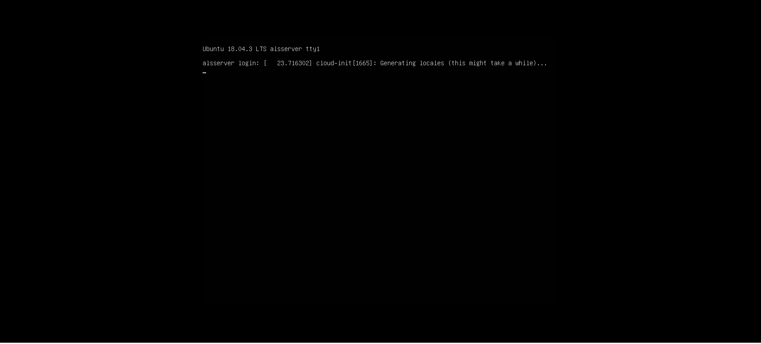

***CentOS Installation Documentation***

Step 1:

Prepare your ISO file for use

Step 2:

Hit next till you get to this screen and hit “Finish”.

Step 3:

Wait till CentOS starts up and pick your language.

Step 4:

After you pick your language, run through the menus that it asks you to look at.

Step 5:

After you have ran through the menus, hit “Begin Installation” and you will be prompted with this screen. Go ahead and set a root password and make a user (If you want).

Step 6:

Wait for the installation to complete and hit “Reboot”.

Step 7:

Wait for reboot and hit enter when prompted with 2 options and then log in

Step 8:

CentOS is now installed, you may log in.

